Rockhampton Bicycle Use Analysis

COIT12209
Data Science

Period Covered: 20/04/2026 – 29/05/2026

May 2026

Word Count:

Lachlan J. W. Wyer (12290303)

COIT12209 Lecturer and Tutor:
Mr. Arjun Neupane
Central Queensland University
Table of Contents
Introduction: 1
Initial Data Exploration: 1
Data Cleaning: 2
Cleaned Exploratory Data Analysis: 3
Temperature and Seasonality: 3
Temperature and Weather: 4
Time Series Analysis 5
Machine Learning 6
Choosing a Model: 6
Checking Data: 6
Model Evaluation: 6
$R2$ and $RMSE$ Metrics: 6
Under vs Over-fitting the Model: 7
Making Predictions: 8
Conclusion 8
Recommendations: 8
References: 10

Table of Tables
Table 1 - Basic number summary 1
Table 2 - Cleaned 4 Number Summary 3

Table of Figures
Figure 1 - Count column boxplot 2
Figure 2 - Large standard deviation columns 2
Figure 3 - The effects of seasonality and temperature affecting the number of bike rentals 4
Figure 4 - Combined effects of the temperature and weather on bike rentals 4
Figure 5 - Time series graph of count 5
Figure 6 – Monthly resampled time series graph of count 6
Figure 7 - Scatter plot of predicted vs actual count values 8

Introduction:
In a time in which cost-of-living, and car and fuel prices are forcing people to explore alternative transportation options. There are three main alternatives that can be utilized within regional and rural areas; public transport (i.e. buses and trains), car-pooling and bicycle riding. The main focus of this will be around bicycle riding. Without the data to find what drives consumer demand, there is no way for councils to prepare for such demand. One such rural council wanting to know this information is the Rockhampton council. As such, they have come forward with some questions to determine:
- Factors driving demand
- Usage through the year
- Whether future demand is possible to be predicted
By knowing the answer to these questions, Rockhampton council hopes to know when to temporarily increase the number of bikes to meet expected demand.

Initial Data Exploration:
As shown in Table 1, as basic 4-number summary and standard deviation was used. This style of summary illustrates clearly wrong data points (e.g. Rockhampton does not get temperatures very below zero) as well as some outlier data points. The clearly wrong data points include temperatures very below 0ºC and max of 100 ºC, humidity below zero and 500%, as well as the Min and Max of count.
The standard deviation also gives an indication on variations around a data points mean. As such most of the different columns within the dataset are considered tight. This is because most of the data’s standard deviation is quite small. However, the count column, counting the number of bicycles used, has a standard deviation of 2016.87. This is very large swings in the data presented around the mean of 77.75.
Table 1 - Basic number summary
 | Min | Max | Mean | Median | Standard Deviation
Holiday | 0.0 | 1.00 | 0.07 | 0.0 | 0.26
Working Day | 0.0 | 1.00 | 0.66 | 1.0 | 0.47
Temp | -25.0 | 100.00 | 22.08 | 21.9 | 6.85
Atemp | 6.0 | 37.72 | 22.42 | 22.5 | 5.25
Humidity | -20.0 | 500.00 | 59.11 | 58.1 | 24.20
Windspeed | 0.8 | 20.30 | 10.43 | 10.3 | 3.26
Count | -100.0 | 50,000.00 | 77.75 | 686.0 | 2016.87
Source – Author (Wyer 2026)
To illustrate these variations presented a box plot is used. The dots illustrate the datapoints that are outliers. As shown in Figure 1, the count as 4 outlier points, drastically increasing until the max point is found. Figure 2 however, is much more contained but still has a significant number of outliers that are both larger and smaller the IQR.

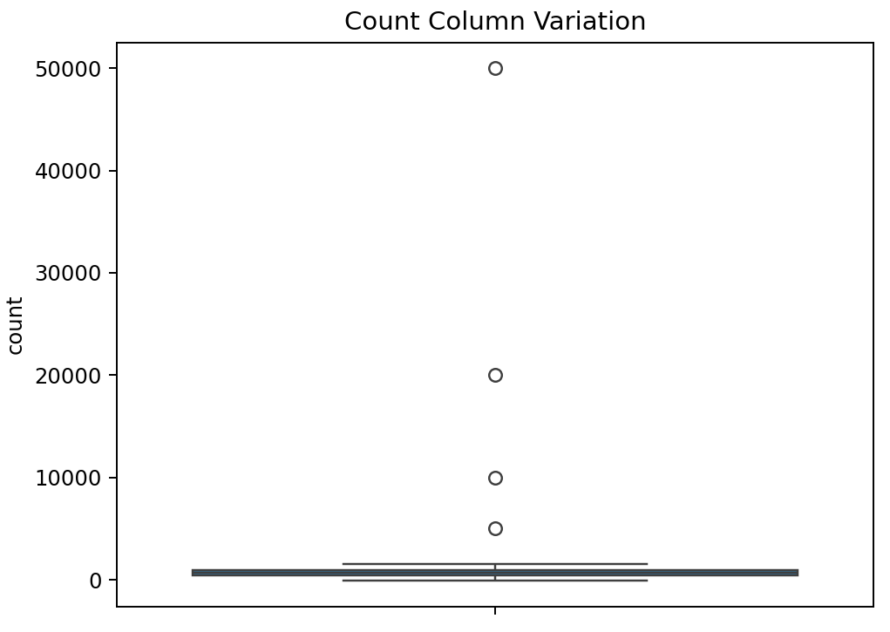
Figure 1 - Count column boxplot
Source – Author (Wyer 2026)
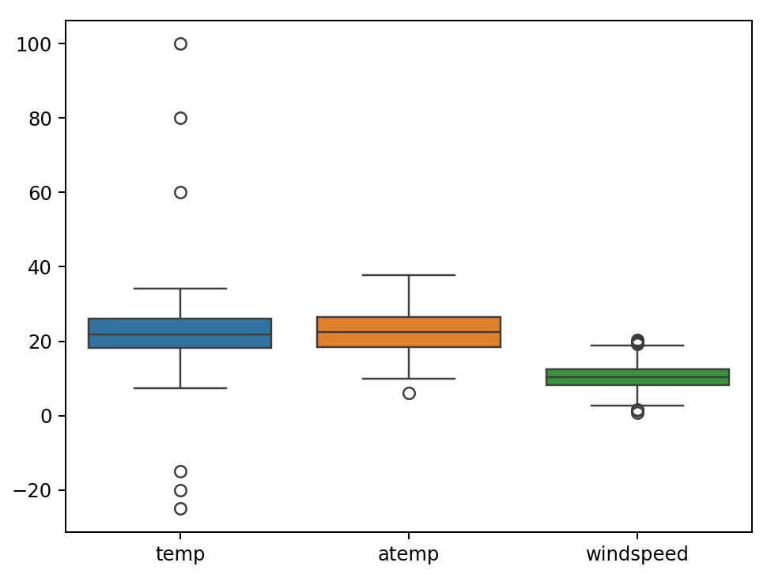
Figure 2 - Large standard deviation columns
Source – Author (Wyer 2026)

It was also found that there were several columns of data that had points missing (~3.45% of the whole column). This will eventually skew the data around the mean and any information presented beforehand. Since the percentage of a column within the dataset as a NULL value is ~3.45%, the rows this is presented in will be replace with that mean from the column. Whilst it would affect the specific accuracy of the dataset, there are not enough NULL values (>5.5%) to require a full rewrite of the dataset (GeeksforGeeks 2026a).

Data Cleaning:
Within the dataset there is only 1 duplicate row. Since this is a duplicated row, simply removing it from the dataset will not affect anything within the dataset.
As mentioned in the section above only 3.45% of some of the columns are NULL values. Here they will be replaced will the mean values within each column (Table 1). This does not affect the overall number summary; however, it might affect some of the trends present within the graph. Knowing that each of the seasons and holidays will affect the overall shape.
To remove obviously incorrect data, only the correct data within 3 standard deviations of the mean (e.g. 99% of the data) will be kept. If the lower bound of the standard deviation is below 0, then it will be changed to 0. This keeping of all data within 3 standard deviations is done twice to make sure that all unlikely outliers are removed from the dataset. In doing this it will inevitably remove some legitimate outliers from the dataset, however to the only way to verify this is compare it another verified correct database. For example, verifying the temperature values against those stored within the Bureau of Meteorology’s database (Queensland Government n.d.). Doing the data cleanse presents the information within Table 2.
Table 2 - Cleaned 4 Number Summary
 | Min | Max | Mean | Median | Standard Deviation
Holiday | 0.0 | 1.00 | 0.07 | 0.0 | 0.26
Working Day | 0.0 | 1.00 | 0.67 | 1.0 | 0.47
Temp | 9.90 | 33.68 | 22.05 | 22.1 | 4.82
Atemp | 10.00 | 34.00 | 22.38 | 22.42 | 5.04
Humidity | 25.53 | 91.40 | 57.75 | 58.40 | 13.01
Windspeed | 2.90 | 17.80 | 10.33 | 10.30 | 3.01
Count | 0.00 | 1522.00 | 678.51 | 710.00 | 313.68
Source – Author (Wyer 2026)

Cleaned Exploratory Data Analysis:

Temperature and Seasonality:
Within cleaned dataset, temperature has the greatest effect on whether people decide to rent a bike. As shown in Figure 3, the highest daily rental numbers (>600) are between 20-27ºC. The number of bike rentals drastically falls off when the temperature is either <18ºC and >28ºC. The seasons do not seem to line up with the temperature and overall do not affect the bike rental numbers, outside of generally determining the seasons temperature. Most people also rent bicycles in summer and winter (Figure 3), with the seasons lining up to when schools/work/people have the largest sets of holidays for use.
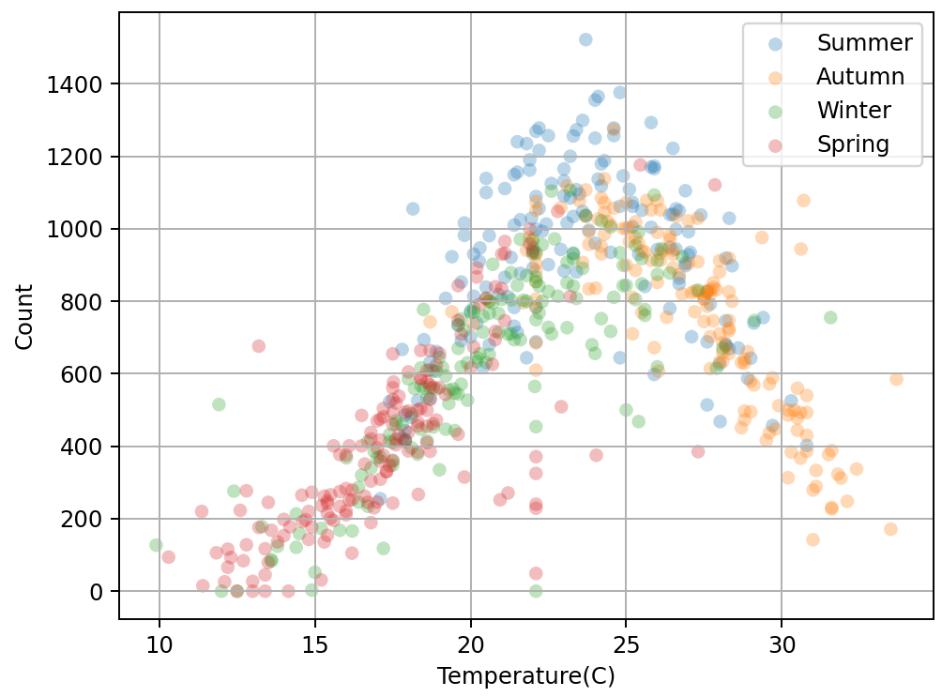
Figure 3 - The effects of seasonality and temperature affecting the number of bike rentals
Source – Author (Wyer 2026)

Temperature and Weather:
The weather seems to have a larger effect on bike rentals (Figure 4). With when rain or high chance of imminent rain is coming bike rental numbers drop comparatively. However, in the overall trends weather is not that much of an impact when the temperature has a much larger impact.

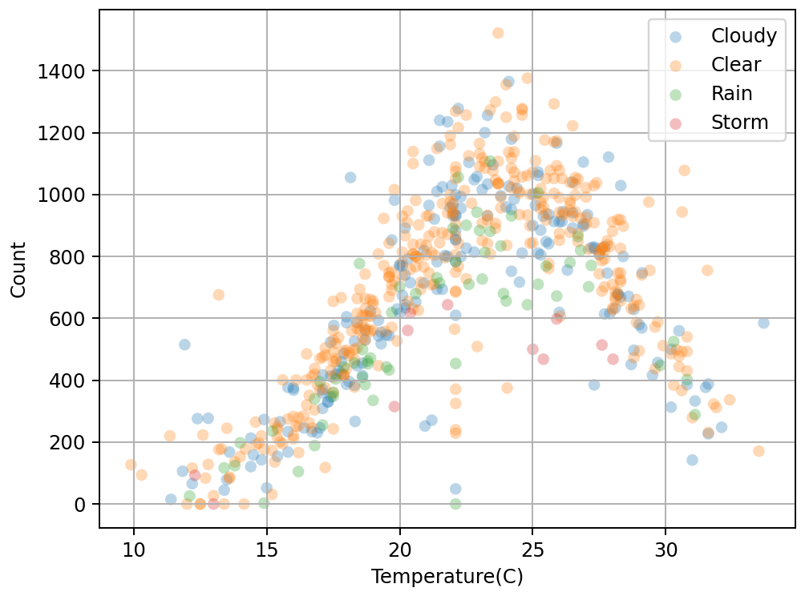
Figure 4 - Combined effects of the temperature and weather on bike rentals
Source – Author (Wyer 2026)

Time Series Analysis
Over the summer holidays (November – March) there is large uptick in the number of bike rentals (Figure 5). This can be attributed to a mixture of parents spending time with their children over Christmas and the children having the spare time over the school holidays. In conjunction with the generally mid temperature (~20-27ºC), overall clear and slightly cloudy weather, contributes to these spikes.
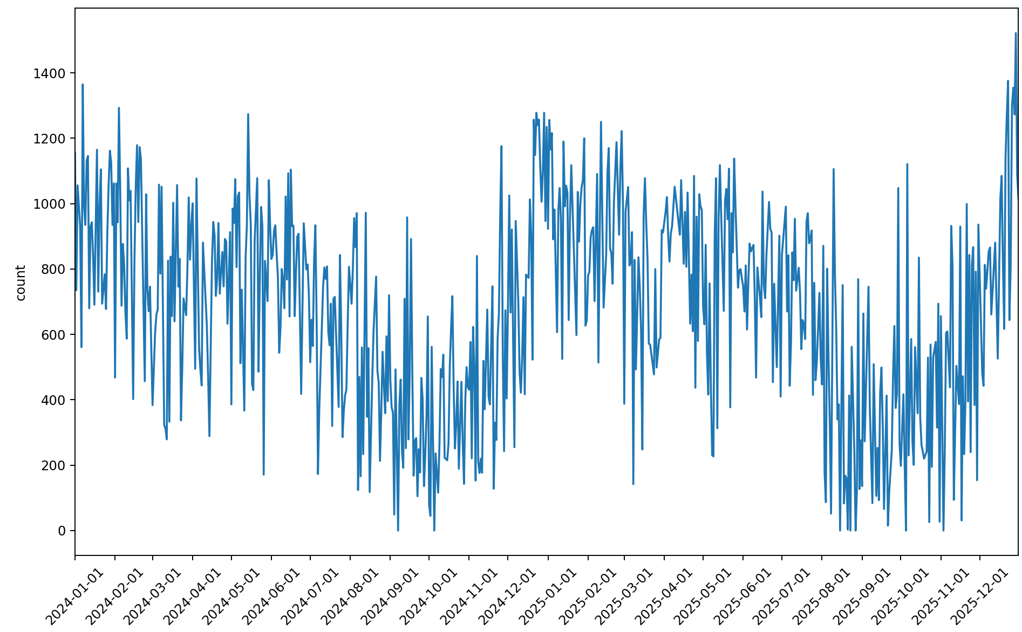
Figure 5 - Time series graph of count
Source – Author (Wyer 2026)
To make the time series analysis a little smoother, a resampling of a mean monthly value is chosen. This smooth out the data, showing clearer trends monthly. However, will lose accuracy in the daily/weekly seasonality changes that occur during the month. In addition, it lost some of the daily outlier spikes, e.g. Figure 5 January spikes ~1350 whereas Figure 6 spikes ~950.
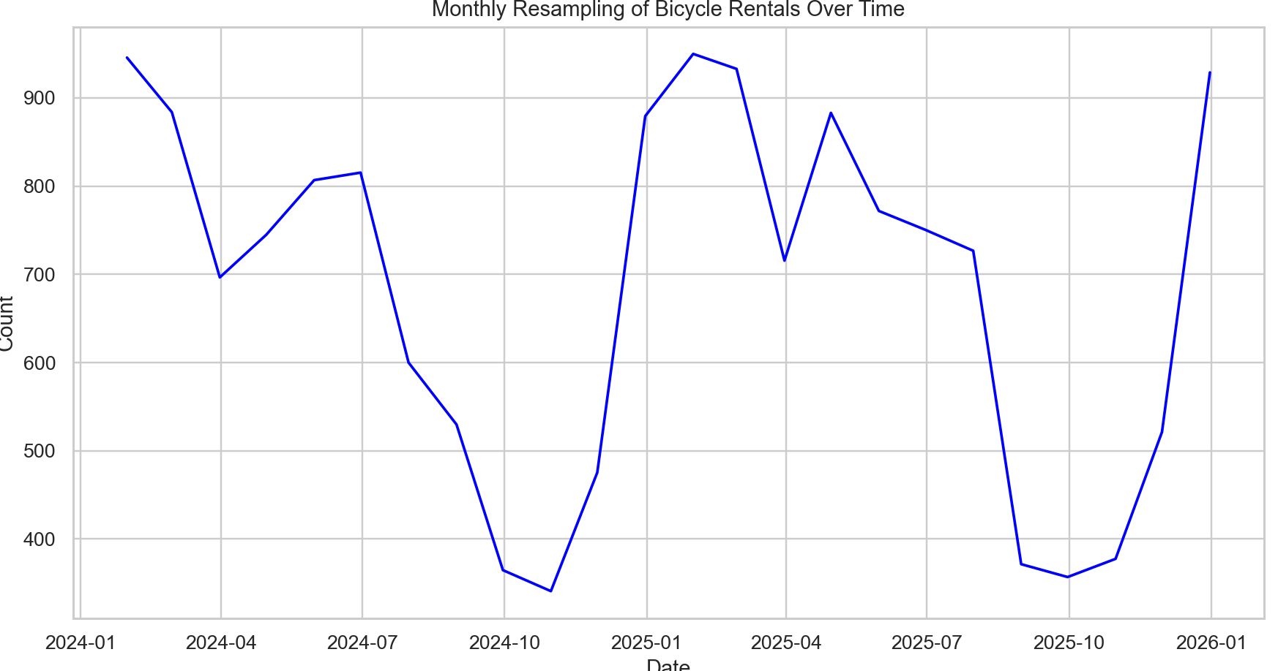
Figure 6 – Monthly resampled time series graph of count
Source – Author (Wyer 2026)

Machine Learning

Choosing a Model:
Here regression analysis was chosen. This is due to the council wishing to predict a numerical outcome (Number of bike rentals), and type of training data. The simplest type, Linear Regression, was chosen to do initial sampling.

Checking Data:
It was found that during the model training period that there were a few values outside of acceptable date ranges, e.g. 29/04/2025. These values were dropped as these values cannot exist within the real world. In the end the “date” column had to be dropped as the linear regression algorithm present within SciKit-Learn (scikit-learn n.d.) cannot take timestamp datatype.
The categorical data within the dataset, also had to be transformed into numerical values. These include the seasons and weather conditions. This transformation turns the from “Summer” or “Cold” into a 0 or 1 value for “season-summer” or “weather-cold” using a transformation matrix.

Model Evaluation:

$R^{2}$ and $RMSE$ Metrics:
The two metrics chosen to evaluate the model are $R^{2}$ and Root Mean Squared Error $\text{(}RMSE)$ (GeeksforGeeks 2026b). Both metrics were chosen as they are the default metrics for regression and can be instantly compared against other regression models. $R^{2}$ values indicate how close a model’s predicted value is to a target actual value. Ideally this value is close to 1 meaning that model is perfect and correlation is linear with not outliers. This models $R^{2}$ value ~0.5119, meaning that there is almost no correlation between X and y values. That value is corroborated by simply looking at the variety (non-linear) expression of the exploratory data analytics graphs. I.E temperature/season/weather against the count and time series graph. As such a linear regression model is not style of basic machine learning required in the non-linear style expressed within the data.
$$R^{2}=1-\frac{\sum_{j=1}^{n}{{\left(y_{j}-\hat{y_{j}}\right)}^{2}}}{\sum_{j=1}^{n}{{\left(y_{j}-\overline{y}\right)}^{2}}}$$
Where:
- $y_{j}$ – Actual Values
- $\hat{y_{j}}$ – Predicted Value
- $\overline{y}$ – Mean of the actual values
The $RMSE$ (Fig B) value penalizes large errors and in particular overestimations. Again, generally the lower the value the more accurate the model. Even with the data cleanse removing the obvious incorrect values, the $RMSE$ value is ~225.75. This value means that there is roughly a $±225.75$ variance error within the model’s prediction.
$$RMSE=\sqrt{\frac{\sum_{j=1}^{N}{{\left(y_{j}-\hat{y_{j}}\right)}^{2}}}{N}}$$
Where:
- $y_{j}$ – Actual Value within the dataset
- $\hat{y_{j}}$ – Model’s predicted value
- $N$ – Number of values

Under vs Over-fitting the Model:
The simple version of under-fitting in when a too simplistic model (e.g. Linear Regression) is trying to predict the complex patterns within a dataset (Non-linear relationships) (Mucci 2024). This is what is happening with the $R^{2}$ and $RMSE$ values mentioned before. The linear regression model trained with the data cannot predict the extremely non-linear patterns within the test and prediction datasets. This is corroborated by the initial data exploration (Figure 3, Figure 4, Figure 5 & Figure 6) showing very non-linear patterns between temperature, seasonality, weather, and time and count.

All of this can be shown in the scatter plot below (Figure 7). With very few predicted values line up with the actual values within the dataset. As, the linear regression model is not great at predicting the non-linear expectation of the data within the dataset.
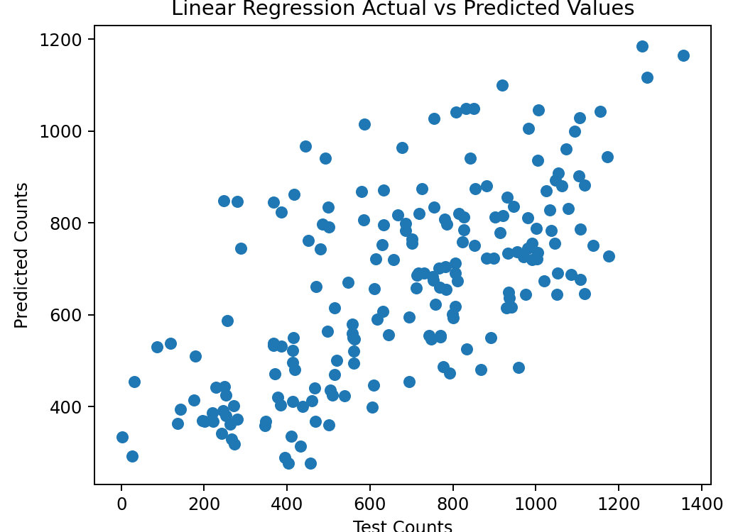
Figure 7 - Scatter plot of predicted vs actual count values
Source – Author (Wyer 2026)

Making Predictions:
Even though it is not recommended to make predictions with this linear regression model, due to terrible $R^{2}$ and $RMSE$ values and severe under-fitting, it still possible. The user inputs a season, whether or not it is a holiday or working day, the temperature, apparent temperature, humidity and windspeed. From these values the linear regression model tries to predict the expected number of bicycle rentals. For example, inputting Summer, public holiday, not working day, clear, temp of 23, atemp of 24, 63% humidity and 43km/h has an expected count of 580.97 (~581) rentals.

Conclusion
With both Rockhampton council and city members exploring alternative transportation options, bicycle rentals is one of the cheapest and most viable options. Having found the factors that appear to drive consumer demand for the rentals, it is now possible for Rockhampton council to try to predict the amount of demand generated. The main factors include temperatures around 21-26ºC, Clear weather and the summer season over the school holidays.

Recommendations:
Whilst it is not currently recommended for council to base decisions off the linear regression model’s predictions, it still possible, and can give some idea to possible number of bike rentals. This is due to seasonality presented in the number of bicycle rentals as well as changes in temperature, season and weather (Figure 3, Figure 4, Figure 5). In future it is possible to change out the linear regression model to something that can deal with this variability and non-linear relationships between factors of bicycle use. These can include a model that will over-fit such as a neural network or even a non-linear regression model such as Support Vector Regression (SVR) (scikit-learn n.d.). As SVR allows polynomial, exponential and trigonometric regression analysis as well as easy hyper-parameter tuning.

References:
GeeksforGeeks 2026a, Data cleaning, GeeksforGeeks, viewed 10 May 2026, https://www.geeksforgeeks.org/data-analysis/data-cleansing-introduction/.
GeeksforGeeks 2026b, Evaluation metrics in machine learning, GeeksforGeeks, viewed 10 May 2026, https://www.geeksforgeeks.org/machine-learning/metrics-for-machine-learning-model/.
Mucci, T 2024, What is overfitting vs. underfitting? | ibm, viewed 13 May 2026, https://www.ibm.com/think/topics/overfitting-vs-underfitting.
Queensland Government n.d., Climate data online - map search, Bureau of Meteorology, viewed 13 May 2026, https://www.bom.gov.au/climate/data/.
scikit-learn n.d., LinearRegression, scikit-learn, viewed 10 May 2026a, https://scikit-learn/stable/modules/generated/sklearn.linear_model.LinearRegression.html.
scikit-learn n.d., SVR, scikit-learn, viewed 13 May 2026b, https://scikit-learn/stable/modules/generated/sklearn.svm.SVR.html.
Wyer, L 2026, BayElectrician/Bike-Use---ML, viewed 10 May 2026, https://github.com/BayElectrician/Bike-Use---ML.

